# UNIVERSITY ADMISSION PREDICTION

# (UAP)

## INDEX

### 1. INTRODUCTION

#### 1.1 Overview

#### 1.2 Objective

### 2. LITERATURE SURVEY

#### 2.1 Existing Problem

#### 2.2 Proposed Solution

### 3. METHODOLOGY

### 4. FLOWCHART

### 5. ALGORITHMS

### 6. ARCHITECTURE

### 7. vantage

### 8. disfavour

### 9. CASE STUDIES

### 10. CONCLUSION

### 

## 

## 

## 1. INTRODUCTION

## a. **Overview**

UAP system is a web based a system. In which, students can register their marks and predict their admissions in college. Using this, the idea of entrance allotment becomes easier and efficient. Many students find it difficult applying for the Colleges.

To minimize the stress of students, we came up with the idea of a website. Which predicts the admissions of a student at a special college, at ease, making the prediction process fast and easy.

### b. **Objective**

UAP is a boon to many students.

This helps the student not only to help in filling out the forms but also give the students an idea about their future college by scheming their cut off. When students are from rural places , they find it hard to do formal procedures. So, this helps them a lot and eases out their fear. This will not only make the admission process easy but also downplay stress for students . The primary objective of this research is to develop a system to solve the problems students are facing,applying for colleges. We will develop a UAP system, which helps the students to predict the chances of their diligence selected for a special college , which they wish to apply based on their profile.

**2. LITERATURE SURVEY**

### 

### a. **Existing Problem**

Today in colleges, student details enter by hand .The student details in separate records are tedious task .There is a chance for more manual errors. The disfavour of existing problem is it requires much man power that is much efforts, much cost and hard to operate and maintain.Since, all the work is done in papers so it is tough to locate a especial student record when it is required.

### b. **Proposed System**

The aim of the proposed system is to address the limit of the current system. The objectives of the proposed system are to Reach a scattered student, Reducing time in action, Centralized data handling. It would help the student to predict the theory of getting selected by the college.

#### 

#### **3. METHODOLOGY**

**Business discernment**: at the start good amount of time was spent on discernment the problem statement by discernment the concerns of students regarding the current process, the objectives of the research were defined in this process.

**Data discernment**: Different features of the data bases on their importance and relevance.

**Data planning:** In this phase, the data from multiple data sources integrates into a final data-set. Further the data was cleaned by removing unwanted columns, performing translation and cleaning action on the data.

**Modelling:** Multiple machine learning models were developed to predict the amount of success of the student’s , in a special college. The user interface was developed to allow the users to access these models.

**valuation:** Models developed are based on their performance . More info will be presented in the valuation section of the paper.

**Deployment:** Once the models were measure they were merged with code developed for user interface using the Bootstrap.

## 4. FLOWCHART

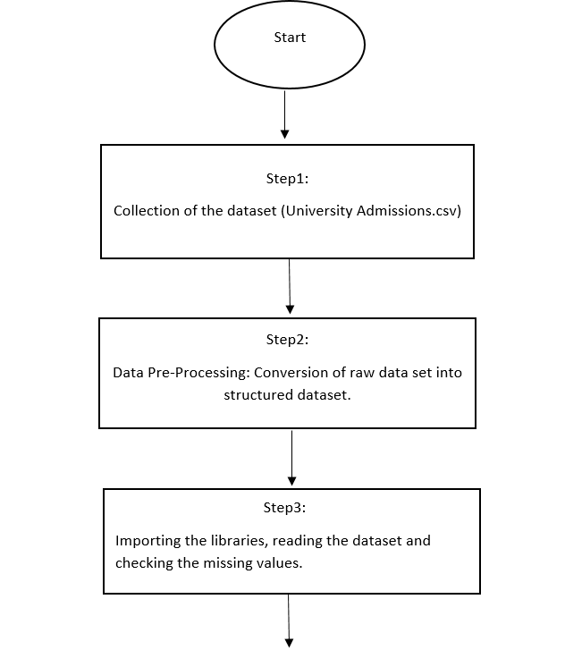

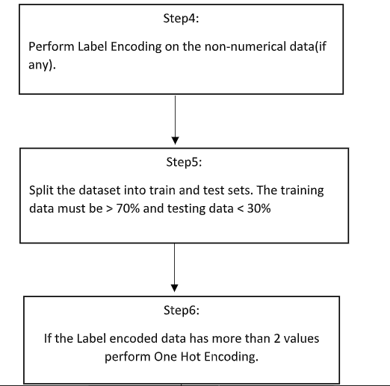



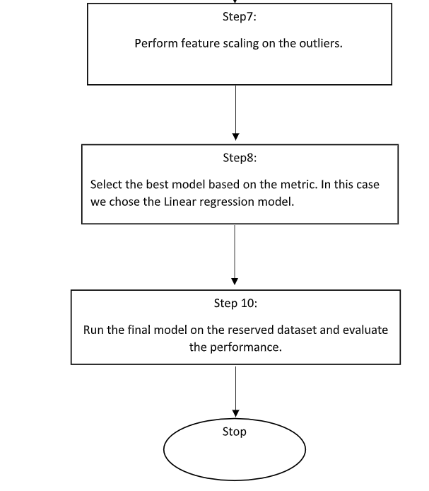

## 5. ALGORITHMS

Multiple machine learning algorithms were used for this research, Linear Regression, Random Forest Classifier algorithms were used to predict the students getting admission into college based on their profile. Decision Tree algorithms was used to predict the rank of the college that would be suitable for the students based on their profile and suggest the list of colleges.

**Random forests** : They are an [ensemble learning](https://en.wikipedia.org/wiki/Ensemble_learning) method for [assortment](https://en.wikipedia.org/wiki/Statistical_classification), [regression](https://en.wikipedia.org/wiki/Regression_analysis) and other tasks that operate by constructing a multitude of [decision trees](https://en.wikipedia.org/wiki/Decision_tree_learning) at training time and outputting the class that is the [mode](https://en.wikipedia.org/wiki/Mode_(statistics)) of the classes (assortment) or mean prediction (regression) of the separate trees. Random decision forests correct for decision trees' habit of [over fitting](https://en.wikipedia.org/wiki/Overfitting) to their [training set](https://en.wikipedia.org/wiki/Test_set).

**Linear Regression:** In statistics, linear regression is a linear approach to modelling the kinship between a scalar response and one or more varying.

**Decision Tree**: It is a supervised machine learning algorithms. Due to its simple logic, strength it is the most widely used sorting algorithms. The model works by creating a tree-like structure by dividing the data-set into several smaller subsets based on different logic. The main components of the decision tree are the decision nodes, leaf nodes and the branches.

## 6. Architecture

#### In this section, we will describe the architecture of the UAP system.

#### 

#### • The student will enter his/her profile details using the user interface developed in website.

#### • The user interface code will interact with the Linear Reggression and Decision Tree models to provide the users with the required result.

#### • The Linear Reggression algorithm be used to determine whether the the student, could get admission in a special college based on his/her profile.

#### • The Decision Tree algorithms will be used to determine the rank of college , which is most suitable for the student based on his/her profile and provide the student with the list of colleges which fall in that rank.

#### • Once the models have been done, the result will be provided to the student as the output on the user interface.

Accuracy was considered to be main metric to measure the performance of the models, as the data used for creating the models was balanced. Also, prediction of the true positive and true negative situations was equally tantamount.

### 7. **Advantages**

1. The principal objective of the research is to help the students who are aspiring to pursue their training.

2. This system will help them to measure the chances of success in a special college without being dependent on any training firm.

3. It will help them in saving a huge amount of time and money spent in the process.

4. Also, it will help them to limit the number of request made by the students, suggesting them the best college where they have high chances of securing admission, thereby by saving the amount of money spent by the students by applying in college ,where they have less chance to secure admit based on their profile .

### 8. **Disadvantages**

UAP system will only consider the data related to chance of admit.

### 

## **9.CASE STUDIES**

Case Study1:

Below is the screen-shot of the website before submitting the student profile.

User has to fill in all the details, the chance of admission is measured and then displayed as result.

## 

## Case Study 2:

## 

## **CASE STUDY 3**

## 

## **CASE STUDY 4:**

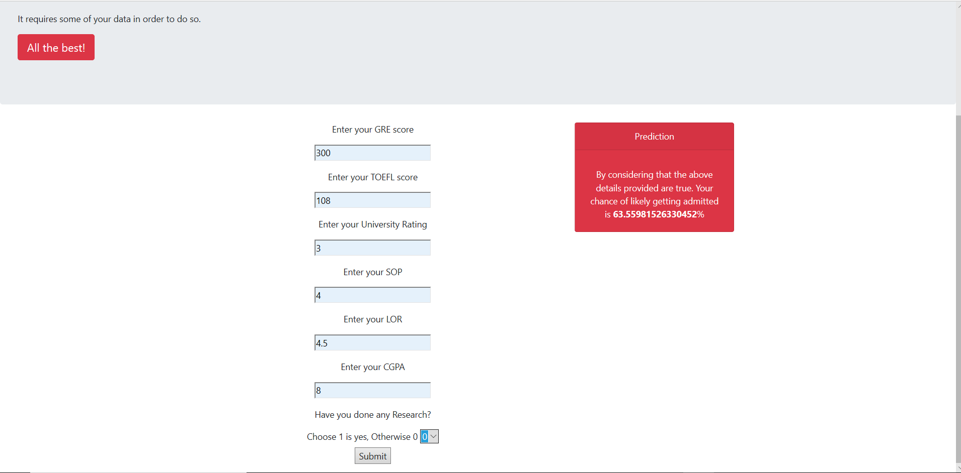

## **CASE STUDY 5:**

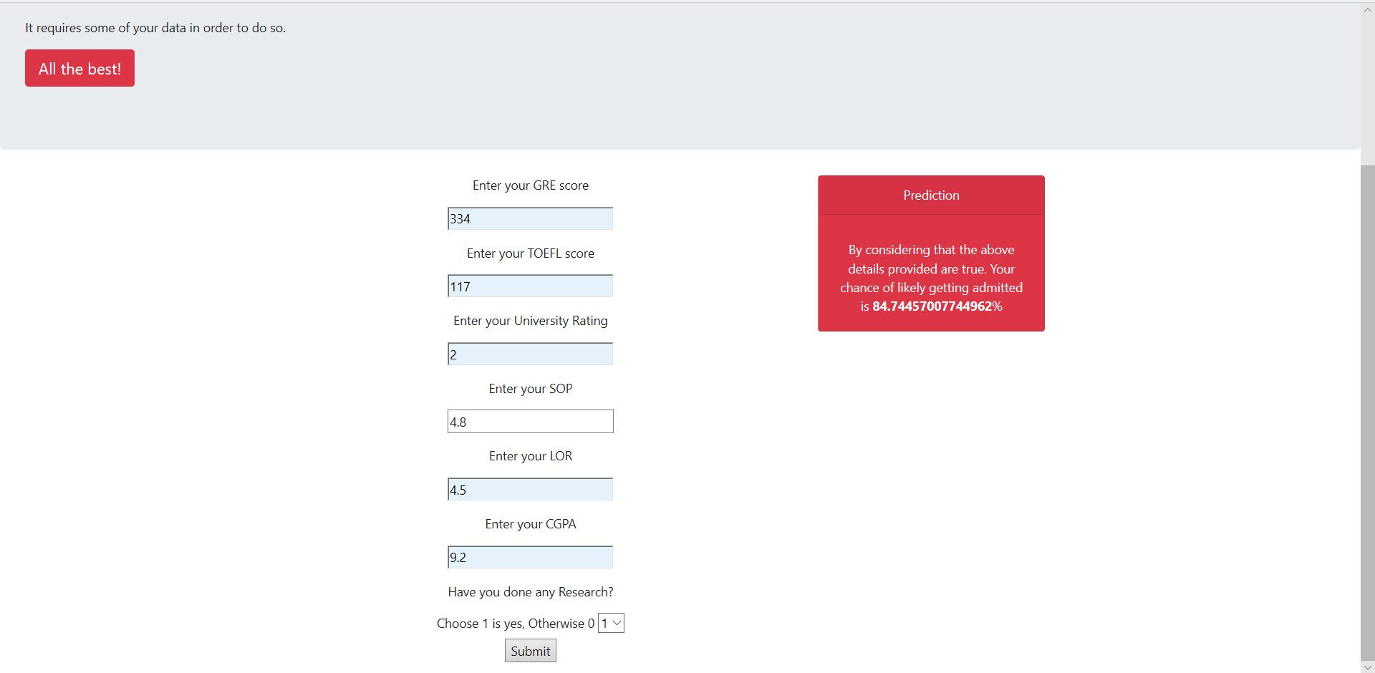

## **Conclusion**

### The main objective of this research was to develop a prototype of the system, that can be used by the students aspiring to pursue their training in the USA. Multiple machine learning algorithms were developed and used for this research.The overall objective of the research was achieved successfully as the system allow the students to save the extra amount of time and money that they would spend on teaching consultants and fees for the college where they have fewer chances of securing admission. Also, it will help the students to make better and faster decision regarding to the college.

As discussed earlier in the limit of the research ,we have created the models based only on the data of Indian Students studying Masters in Computer Science in the USA, we have considered only ten college with different rankings.